# Diabetes Classification Results using GradientBoosting

## Classification Report:

precision recall f1-score support  
  
 0 0.83 0.75 0.79 146  
 1 0.78 0.86 0.82 154  
  
 accuracy 0.80 300  
 macro avg 0.81 0.80 0.80 300  
weighted avg 0.81 0.80 0.80 300

## ROC AUC Score:

ROC AUC Score (GradientBoosting): 0.8675947340330903

## ROC Curve:

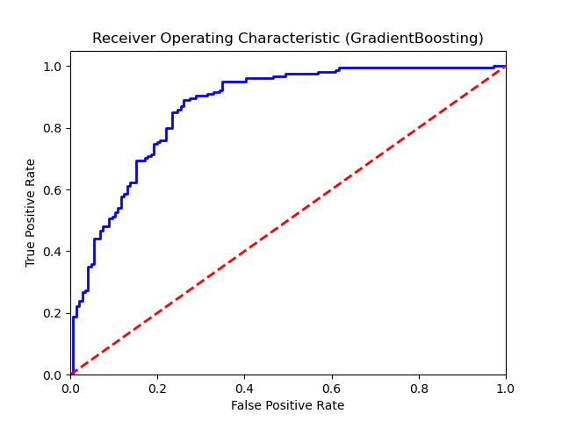

## Confusion Matrix:

True Negatives: 109

False Positives: 37

False Negatives: 22

True Positives: 132

## Confusion Matrix Plot:

